Actividad integradora 1. My Curriculum Vitae

APPLICATION FORM

Personal information
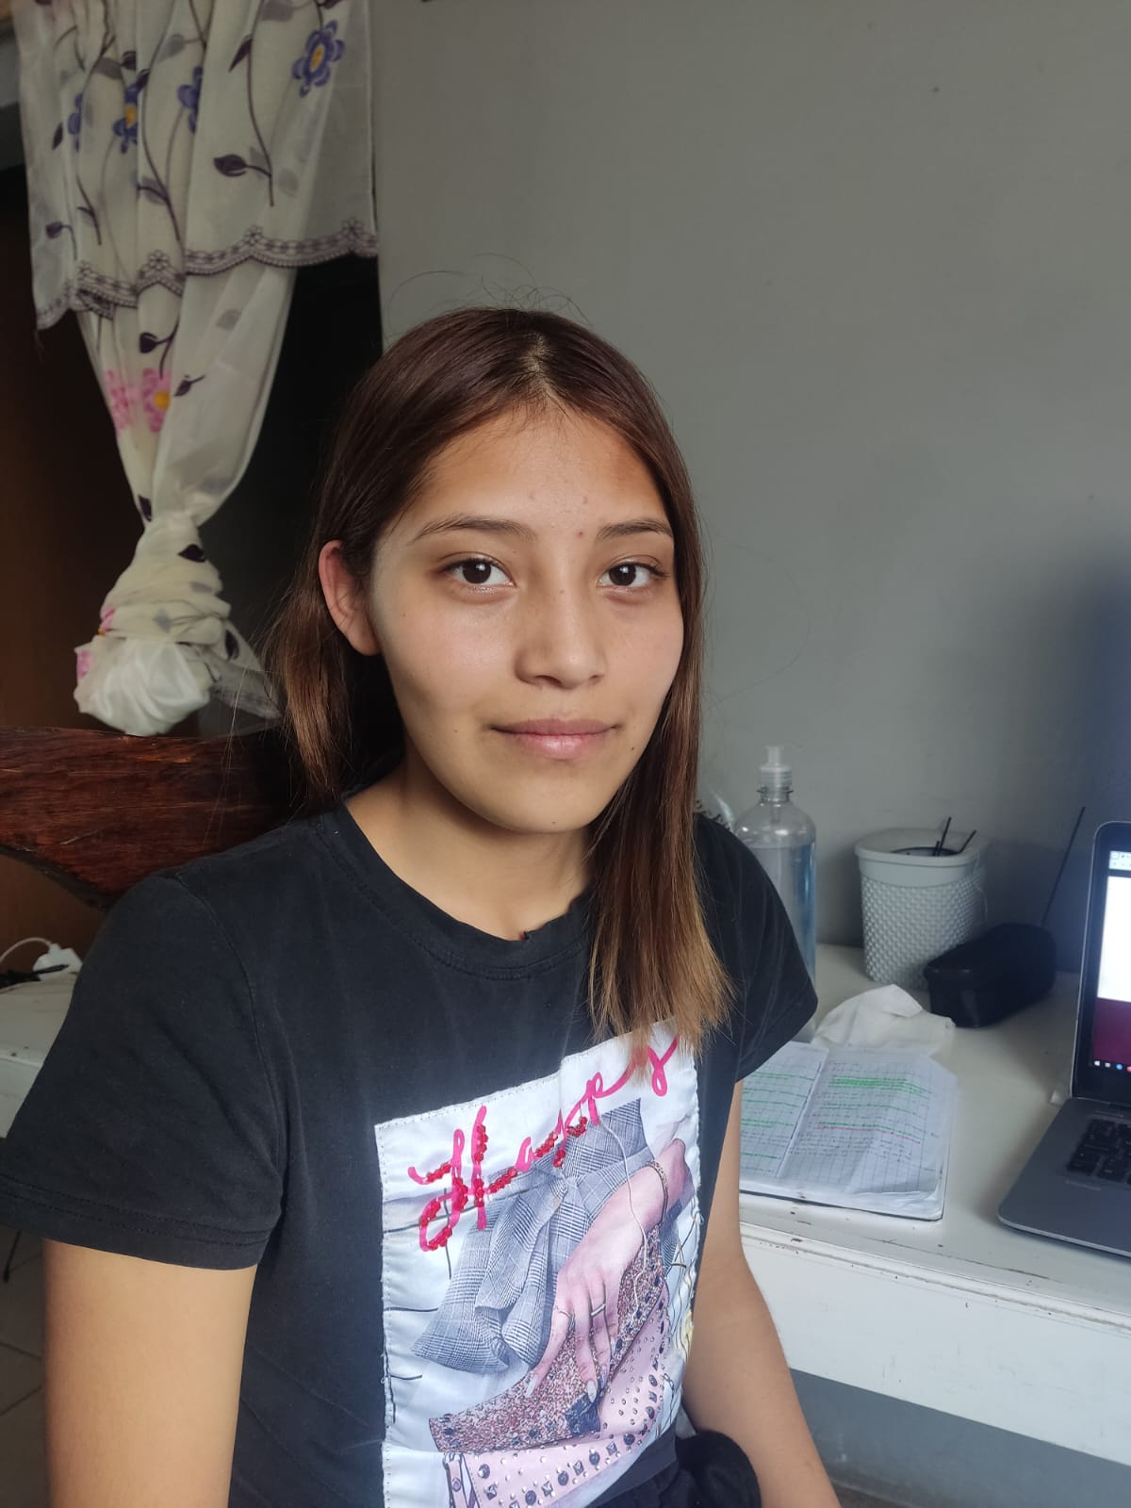
Last name | First name |  | Middle name
Analia | Perez |  | Perez
Address
Street Number City State Zip code
Cuahuatemoc | 4 | Puebla | Puebla |  | 74104
Telephone number | Email | Nationality |  | Age
2215732601 | 251840141@  prepaenlinea.  sep.edu.mx | Mexicana |  | 16
Occupation | Birth date
Student | 04/17/2010

In two lines, describe your best personality qualities and your physical appearance.
(For example: I am intelligent, active, friendly and funny. I’m short and thin. I have brown eyes, medium curly hair and small mouth.)
I consider myself intelligent, calm, and positive. I am tall and thin. I have straight black hair, dark eyes, and a big smile.

Describe the characteristics of your house as a reference.
(For example: My house is orange with a brown door and it has a big tree next to it.)
My house is small, blue, and has two stories (it is not made of wood). It is located close to both the park and the elementary school.

My audio o URL
(Copy the URL of your audio here.)

No es necesario que incluyas tu dirección real; puedes inventar alguna. El objetivo es que practiques la forma en que se debe trabajar un formato de este tipo. En la foto te sugerimos que incluyas la misma que tienes en la plataforma.

